# Terms and Conditions

# FRONT COVER:

## LEGAL NOTICE

The Publisher has strived to be as accurate and complete as possible in the creation of this report, notwithstanding the fact that he does not warrant or represent at any time that the contents within are accurate due to the rapidly changing nature of the Internet.

While all attempts have been made to verify information provided in this publication, the Publisher assumes no responsibility for errors, omissions, or contrary interpretation of the subject matter herein. Any perceived slights of specific persons, peoples, or organizations are unintentional.

In practical advice books, like anything else in life, there are no guarantees of income made. Readers are cautioned to reply on their own judgment about their individual circumstances to act accordingly.

This book is not intended for use as a source of legal, business, accounting or financial advice. All readers are advised to seek services of competent professionals in legal, business, accounting and finance fields.

You are encouraged to print this book for easy reading.

# Table Of Contents

Foreword

Chapter 1:

Eat Littler and Better Meals

Chapter 2:

Physical Activity Regularly

Chapter 3:

Learn New Things Daily

Chapter 4:

Stimulate Your Brain With Games

Chapter 5:

Find Your Passion

Wrapping Up

# Foreword

I think that energy management and the power to use your own energy is among the most crucial keys to effectiveness. Although our power to organize our time is limited to the number of hours in the day, our elemental potential for bettering energy has far fewer physical limitations. Being able to better your energy capability and your power to use that energy effectively will have a big affect on your results.

To help out with this I've listed ways you are able to either better your energy capacity or better control the energy you already have. I've tried to provide advice that covers all 4 properties of human energy in physical, emotional, mental and spiritual arenas. I've personally tried all of these strategies and I've discovered them to be incredibly effective in bettering my own energy.

***Energy Extravaganza***

***Learn how to increase mental clarity and feel the power of unlimited energy in this hectic world.***

# Chapter 1:

***Eat Littler and Better Meals***

# Synopsis

Healthy eating isn't about strict nutrition doctrines, remaining unrealistically thin, or depriving yourself of the foods you love. Instead, it’s about feeling excellent, having more energy, and keeping yourself as healthy as possible– all of which can be accomplished by learning a few nutrition basics and utilizing them in a way that works for you.

Healthy eating starts with learning how to “eat smart”—it’s not just what you eat, but how you eat. Your food picks may reduce your risk of illnesses like heart disease, cancer, and diabetes, as well as defend against depression. In addition, learning the habits of healthy eating may boost your energy, sharpen your memory and stabilize your mood.

## Food Choices

Meat, eggs, fish, fowl, nuts and seeds give you the power you need to get things done. Put walnuts and butter on your rolled oats, not maple syrup and raisins. For afternoon power, eat a low-carbohydrate, high-protein lunch like stir fried chicken with broccoli. Avoid pasta-only meals.

Seek grass-fed meats and free-range fowl. These protein sources are more fertile in several vitamins and omega-3 fats, which are crucial to energy and health. Factory produced animal frequently harbor diseases from overcrowded and unsanitary living conditions, in addition to as unhealthy hormone and chemical residuals.

Cooked spinach, broccoli, kale, collards, mustard greens, chard, bok choy, beet greens, Chinese broccoli are all power boosters, with chlorophyll, magnesium and B vitamins.

Drink adequate H2O. The amount you require varies by individual. Signs you have to drink more include thirst, dark/deep yellow urine, fatigue, mental fuzziness, dry skin and constipation. Avoid cold water, which retards digestion. Avoid sweet and unnaturally sweetened drinks. Make certain your water is free of added fluoride, which may suppress thyroid (and therefore energy and metabolism) and free of pollutants.

Most people consume 2 to 3 meals a day, often going hours without eating and then gorging themselves every time they eat. Most nutritionists now advise that eating 5 or 6 meals a day is superior whether you're looking to slim down, or even build muscles. By consuming littler sized meals throughout the day you provide your body with a ceaseless supply of nutrients and you reduce the chance that you'll overeat. Although I have not yet made this eating style a total habit in my life yet, I have done some prelim personal experiments that show its effectiveness.

The major advantage of eating lower meals throughout the day comes in the benefit to your energy reserves. Digestion is among the major drains on your power supplies. Eating littler meals throughout the day lessens the incredibly high energy drain affiliated with consuming a big meal.

Moreover, eating 5 or 6 meals daily provides the body with a more continuous supply of nutrients to steady energy supplies. Although eating littler meals won’t make up for awful dietary habits, it may be a great way to better the diet you already have.

This might seem like a hard habit to install given our fast paced lives where most individuals don’t have the time to cook 2 healthy meals a day never mind 6, so I can offer a couple of suggestions for reducing the time cost from this habit. Begin by cooking meals beforehand. If you fix healthy food only once the entire day and reheat it later, you are able to save yourself some time. You may likewise merely split up your regular meals into halves, eating the other half a few hours after your first meal. You might have to be creative in organizing your efforts to install this habit, but the power advantages make it well worth it.

# Chapter 2:

***Physical Activity Regularly***

# Synopsis

The body is an astonishing thing. Each part of the body impacts every other part, which is why the act of healing needs to encompass the whole body.

Yes, physical exercise arouses the brain and may boost your mental clarity.

Exercise increases blood flow and therefore circulates more oxygen to the brain, raising brain serotonin and energy levels.

It’s likewise been shown to slow the loss of brain tissue as you age. Even 15 minutes of physical activity a couple of times a week has been shown to cut down the risk of dementia in the elderly.

## Get Moving

This one isn’t a big surprise, but as far as physical energy goes, physical activity is likely the most important factor. Exercise stresses the physical body so that when given suitable recovery time the body gets to be stronger, yielding more energy.

By exercising on a regular basis with strength, aerobic and flexibility training you are able to gain a huge boost to your energy levels while staving off many diseases and bettering general health.

Exercise likewise releases endorphin, which itself brings on a boost in energy. I frequently find the best time to do energy consuming work is right after exercising because of this fact. Endorphin is likewise a powerful pain killer and broadly betters your mood. In more ways than one, exercise is among the best ways to better your energy.

All health professionals agree that any exercise is better than no exercise. If you don't exercise at all, try taking little steps. Begin by taking a 10 minute walk a few times a week. As you become more used to the action, take longer walks, or walk faster.

If walking isn’t your thing, join a gymnasium and try out some fun classes. Fields of study have demonstrated that even 15 minutes of exercise a few times a week is beneficial. Ideally you ought to have 30 minutes of exercise at least 4 or 5 times a week, varying between cardiovascular and strength training.

Exercise abbreviates stress and helps to relax you. A reduction in stress will help lower blood pressure. Stress likewise adversely affects your immune system, making stress reduction a crucial priority.

Exercise increases your stamina as well as bone and muscle strength, flexibleness and balance, which becomes more crucial as you age. Serotonin levels better with exercise so risk of depression is reduced.

It’s intriguing to note that when individuals engage in regular physical activity, they tend to take better care of their bodies. Those who exercise tend to consume a more balanced diet, and have lower cholesterol and blood pressure levels than those who don't.

# Chapter 3:

***Learn New Things Daily***

# Synopsis

The mental aspect of our energy will ascertain how effectively we may utilize the physical capacity of energy. A commitment to learning fresh things every day is among the most beneficial ways to keep your mental energies sharp.

Although there's inherent value in the added knowledge gained from learning, the action of learning itself may be an excellent way to better your mental energies.

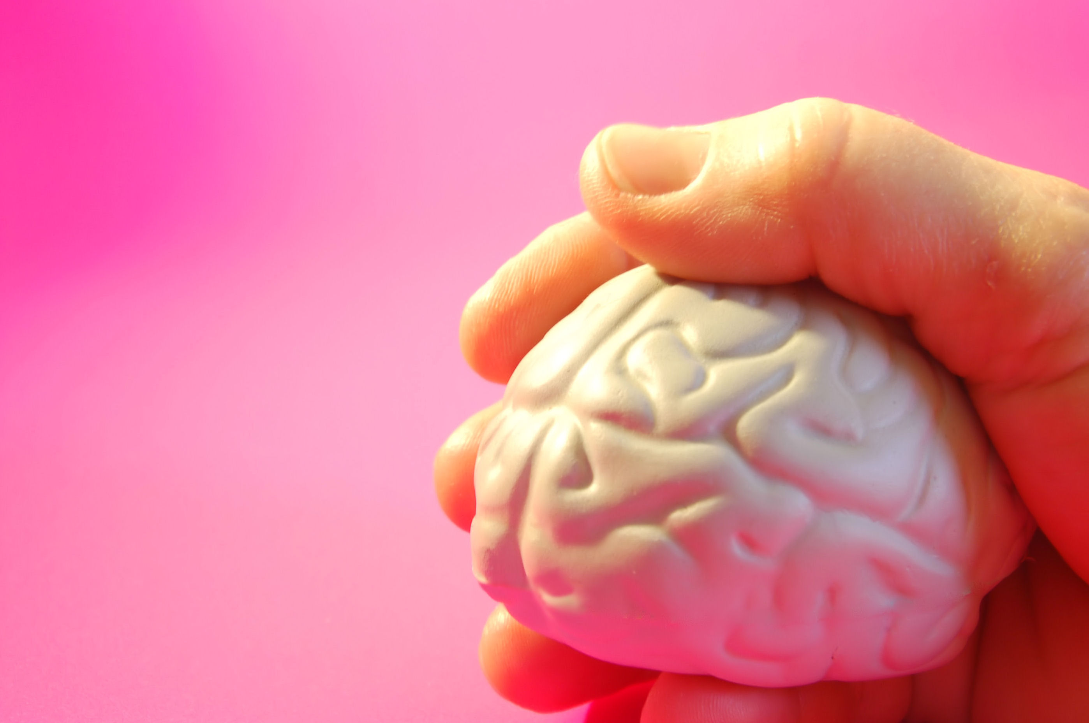

## Challenge Your Brain

If you don’t already read at any rate one non-fiction book a month, make that your resolution. I personally read anyplace from 1-2 books a week, almost all of the time non-fiction.

Although fiction may be an excellent way to stimulate the imagination, there are a lot of ways you are able to do that, but unluckily the mental learning gained from non-fiction books doesn’t bear as many alternatives.

Learning doesn’t even have to be directed toward a particular purpose. Even if you don’t have to learn anything fresh to maintain the point you are in your life right today, pick up something you find intriguing and learn about it anyways.

Many individuals never pick up another book after they leave senior high school. Learning has to be a lifelong habit, not simply a chore to get a degree.

Most of our social circles are limited to individuals inside our same age range or have like interests. Interacting with these individuals will not bring you fresh experiences and chances.

There are reasons why networking sessions are so powerfully recommended. They bring diverse individuals together who are interested in meeting more individuals. Every participant gets multiple chances to learn something new, either from the speaker or their peers. If you're less inclined in meeting individuals, attempt surfing to some internet forums you've never been to before.

Go to a class. Sign up for a class. Dance classes, hobby related classes appear really popular to individuals who have a bit more time. They may have something of interest to you too. There are numerous places on the internet to learn something new.

Acquire a hobby. This is an additional great way to try something new. Some individuals likewise manage to successfully turn their hobby into part time businesses.

Study every article in your newspaper. Have you been guilty of scanning article titles and only reading the ones you've interest in? You paid the full price for the paper so make full use of it. Study each article. It may take you a whole hour by the price is well spent. Newspaper articles are commonly well researched and have quality writing in them. That’s something you won’t find on the net consistently.

This preview copy ends here and to get the full product, please go to (the website URL ) here to get the full product.